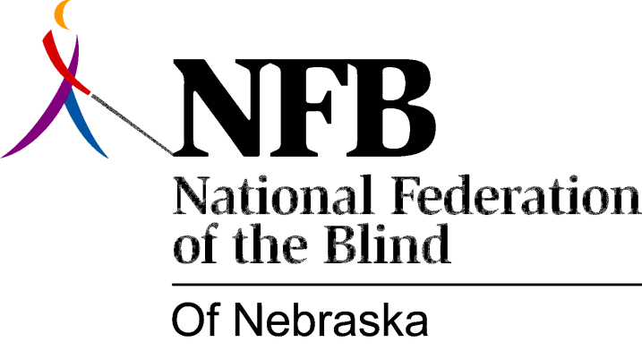

Resolution 1977 – 01
Re: Creation of an Advisory Committee to the Nebraska School for the Visually Handicapped

WHEREAS, The National Federation of the Blind of Nebraska believes that all blind children have the right to a full and formal education and that it is essential that the educational process stress the truth about blindness thus enhancing the development of a positive attitude toward themselves and blindness; AND

WHEREAS, Any educational institution should receive input from knowledgeable sources concerning its programs; AND

WHEREAS, The National Federation of the Blind of Nebraska believes that the blind themselves can best determine their needs and are therefore best qualified to assess current thought and planning concerning educational programs for the blind; AND

WHEREAS; Jerry Regler, Superintendent of Nebraska School for the Visually Handicapped, has indicated to the National Federation of the Blind of Nebraska Liaison Committee to Nebraska School for the Visually Handicapped that he would support the creation of an advisory committee to Nebraska School for the Visually Handicapped; NOW, THEREFORE,

BE IT RESOLVED by the National Federation of the Blind of Nebraska in Convention Assembled this 14th Day of May 1977 in the city of Lincoln, Nebraska that the Legislative committee of this Organization be instructed to propose legislation in the 1978 session of the legislature of Nebraska to create such a committee; AND,

BE IT FURTHER RESOLVED that the committee work with Mr. Jerry Regler, Staff and Faculty of the Nebraska School for the Visually Handicapped, the Nebraska Department of Education, Alumni, and parents, and any other persons who demonstrate genuine interest in such a committee, AND

BE IT FURTHER RESOLVED that such legislation provide for representation form organization of the blind, alumni, parents of students, and students, and that at least 75 percent of the committee be blind.

Passed Unanimously May 14, 1977

