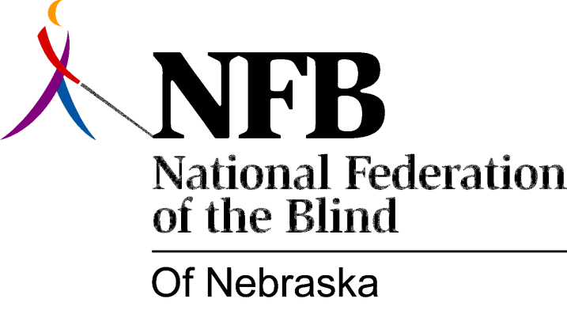

Resolution 1976 – 09
Re: Equal Access to Housing Accommodations

WHEREAS, the National Federation of the Blind of Nebraska believes that blind persons are entitled to the full rights of citizenship, including the right to full and equal access to housing accommodations, and,

WHEREAS, the 1975 Unicameral passed L.B. 83 to insure such rights to blind people, and this legislation was approved by the governor on March 4th, 1975, and,

WHEREAS, a recent case of housing discrimination occurring in Lincoln, Nebraska directly violated this legislation, and was subsequently successfully prosecuted by the Lancaster County Attorney’s office, now, therefore,

BE IT RESOLVED, that the National Federation of the Blind of Nebraska, in convention assembled this 16th day of May, 1976, in the city of Grand Island, Nebraska, Commend the Lancaster County Attorney’s office, and specifically Mr. Rodney J. Ream, the prosecuting attorney in this case, fore their recognition of the inherent rights of blind persons to be considered first-class citizens, and for their efforts and perseverance in following through with their convictions by successfully prosecuting this case of housing discrimination on April 27, 1976, and,

BE IT FURTHER RESOLVED, that the secretary be instructed to send copies of this resolution to the Lancaster county attorney’s office, and to Mr. Rodney J. Ream.

This Resolution Passed Unanimously.

