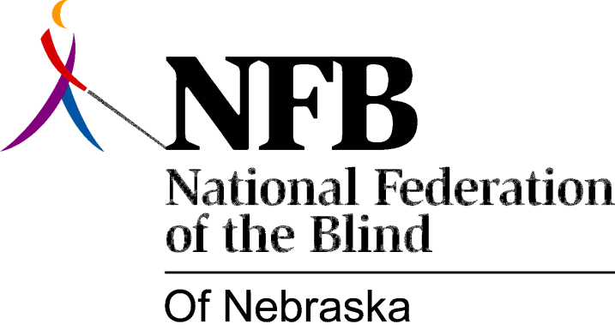

Resolution 1976 – 01
Re: Nebraska Library Commission

WHEREAS, The National Federation of the Blind of Nebraska believes that the Library for the Blind and Physically Handicapped plays a paramount role in the lives of blind people, and,

WHEREAS, we believe that library services should strive to meet the reading, informational and, particular library needs of its consumers, and,

WHEREAS, the Nebraska Library for the Blind and Physically Handicapped is currently administered by the Library Commission, whose power it is to establish procedures and formulate policies, and,

WHEREAS, this power directly affects the quality of library services and therefore, the lives of blind consumers throughout Nebraska, and,

WHEREAS, the National Federation of the Blind of Nebraska is the largest and most representative consumer group of the blind in Nebraska, therefore,

BE IT RESOLVED, by the National Federation of the Blind of Nebraska, in convention assembled this 15th day of May, 1976, in the city of Grand Island, Nebraska, that we urge the Nebraska Library Commission to establish regular and formal contacts with an appointed representative committee of the National Federation of the Blind of Nebraska for the purpose of improving library services to all consumers.

Resolution passed unanimously

